Storage Account:
Azure Storage is a Microsoft-managed service providing cloud storage that is highly available, secure, durable, scalable, and redundant. Azure Storage includes Azure Blobs (objects), Azure Data Lake Storage Gen2, Azure Files, Azure Queues, and Azure Tables.
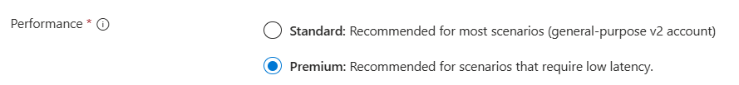
Premium Will support LRS and ZRS only for Redundancy bcoz low latency
Standard Will Support LRS,ZRS,GRS,GZRS

Standard general-purpose v2
Standard storage account type for blobs, file shares, queues, and tables.
Queue Storage: To storing large numbers of messages. Provides a messaging solution for asynchronous communication between application components and Microservies
Table Storage: is a NoSQL data with a schema-less design. Suitable for storing large amounts of non-relational data, such as user metadata or device information.
Premium block blobs
Premium storage account type for block blobs and append blobs. Recommended for scenarios with high transactions rates.
1. Block Blob: Blob Storage is essentially a service for storing large amounts of text or binary data, such as images, audio, video files, and other types of unstructured data.
It supports RESTful APIs, making it accessible from anywhere.
2. Append Blob: Log files, real-time analytics, IoT data streams.
Each blob can be up to 4.77 terabytes in size. Users may access blobs via HTTP or HTTPS using a unique URL, and a user can authenticate them using Azure Active Directory or a shared access signature.
If you have an analytics use case, we highly recommend that you use Azure Data Lake Storage along with a premium block blob storage account.
To unlock Azure Data Lake Storage capabilities, enable the Hierarchical namespace setting in the Advanced tab of the Create storage account page.
Premium file shares
Premium storage account type for file shares only. Recommended for enterprise or high-performance scale applications. Use this account type if you want a storage account that supports both Server Message Block (SMB) and NFS file shares.
Premium page blobs
Used primarily for VHD (Virtual Hard Disk) files that serve as disks for Azure virtual machines. They can be up to 8 TiB in size
Page blobs can only use the Hot access tier, they cannot use either the Cool or Archive tiers

Locally redundant storage(LRS)
Three copies across one or more availability zones within a region
Zone-redundant storage(ZRS)
Three copies across separate availability zones within a single region
Geo-redundant storage (GRS)
Six copies total, including three in the primary region and three in the secondary region
Geo-zone-redundant storage (GZRS)
Six copies total, including three across separate availability zones in the primary region and three locally redundant copies in the secondary region

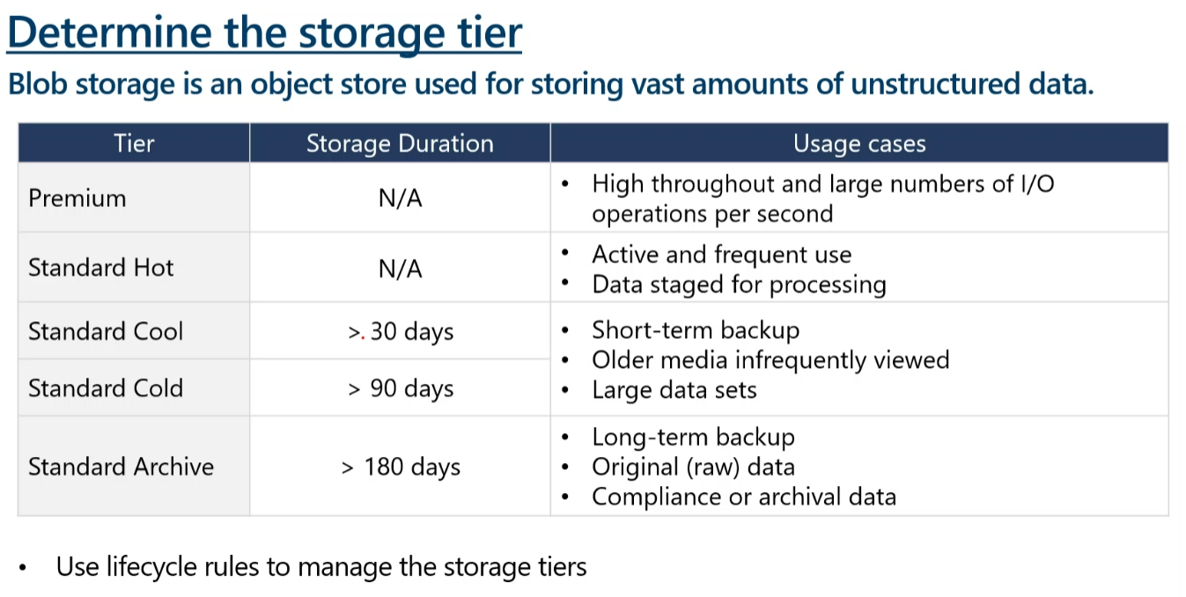
- Hot tier - An online tier optimized for storing data that is accessed or modified frequently. The hot tier has the highest storage costs, but the lowest access costs.
- Cool tier - An online tier optimized for storing data that is infrequently accessed or modified. Data in the cool tier should be stored for a minimum of 30 days. The cool tier has lower storage costs and higher access costs compared to the hot tier.
- Cold tier - An online tier optimized for storing data that is rarely accessed or modified, but still requires fast retrieval. Data in the cold tier should be stored for a minimum of 90 days. The cold tier has lower storage costs and higher access costs compared to the cool tier.
- Archive tier - An offline tier optimized for storing data that is rarely accessed, and that has flexible latency requirements, on the order of hours. Data in the archive tier should be stored for a minimum of 180 days
🚫 ARCHIVE Tier
- Purpose: Long-term, rarely accessed data (e.g., compliance logs, archived files).
- Access Speed: Not immediate.
- Cost: Lowest storage cost, highest access cost.
- ❌ Access: Not immediate!
  - You must re-hydrate the blob to Hot or Cool before accessing it.
  - Rehydration takes several hours (up to 15 hours).
- ❌ Archive tier is not supported on Azure File Share.
- Azure File Shares support Hot, Cool, and Transaction Optimized tiers, but not Archive — and no rehydration process.

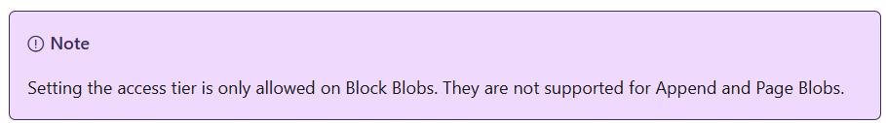
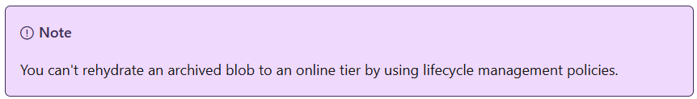
Notes:
250 Storage Accounts can be created per Subscription per region.

Access Keys are used to authenticate the applications when making requests to this Azure storage account. These are like master keys for accessing the entire Storage Account.
Shared Access Signature is used to provide authentication on various Storage Services and Objects. SAS provide a very granular level access. SAS provide the below.
- What Azure services the client can access
- How long the SAS should be valid
- From which IP Address the client can access the Storage Services
- What permissions (Read / Write/ Delete / List) does the client can have.

Customer-managed planned failover (preview)
Planned failover can be utilized in multiple scenarios including planned disaster recovery testing, a proactive approach to large scale disasters, or to recover from nonstorage related outages.
During the planned failover process, the primary and secondary regions are swapped. The original primary region is demoted and becomes the new secondary region. At the same time, the original secondary region is promoted and becomes the new primary. After the failover completes, users can proceed to access data in the new primary region and administrators can validate their disaster recovery plan. The storage account must be available in both the primary and secondary regions before a planned failover can be initiated
Microsoft-managed failover
A Microsoft-managed failover would be initiated for an entire physical unit, such as a region or a datacenter. It can't be initiated for individual storage accounts, subscriptions, or tenants.
Anticipate data loss and inconsistencies
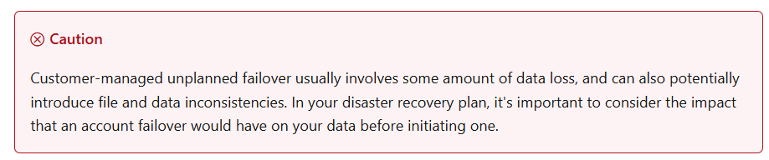

Azure Storage encryption for data at rest
Azure Storage uses service-side encryption (SSE) to automatically encrypt your data when it's persisted to the cloud
Azure Storage encryption is enabled for all storage accounts, including both Resource Manager and classic storage accounts. Azure Storage encryption cannot be disabled. Because your data is secured by default, you don't need to modify your code or applications to take advantage of Azure Storage encryption.
Data in Azure Storage is encrypted and decrypted transparently using 256-bit AES encryption, one of the strongest block ciphers available, and is FIPS 140-2 compliant.

You can specify a customer-managed key to use for encrypting and decrypting data in Blob Storage and in Azure Files.^{1,2} Customer-managed keys must be stored in Azure Key Vault or Azure Key Vault Managed Hardware Security Module (HSM).
Customer-managed key Encryption Supports only Blob Storage, Azure Files
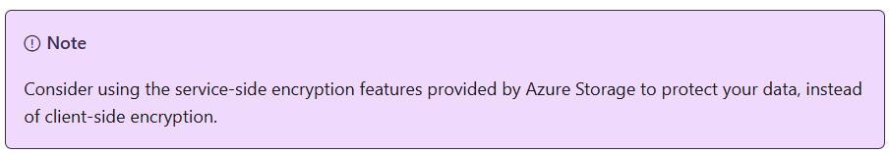

Store business-critical blob data with immutable storage in a write once, read many (WORM) state
Immutable storage for Azure Blob Storage enables users to store business-critical data in a WORM (Write Once, Read Many) state. While in a WORM state, data can't be modified or deleted for a user-specified interval. By configuring immutability policies for blob data, you can protect your data from overwrites and deletes.
- Time-based retention policies: With a time-based retention policy, users can set policies to store data for a specified interval. When a time-based retention policy is set, objects can be created and read, but not modified or deleted. After the retention period has expired, objects can be deleted but not overwritten.
- Legal hold policies: A legal hold stores immutable data until the legal hold is explicitly cleared. When a legal hold is set, objects can be created and read, but not modified or deleted.

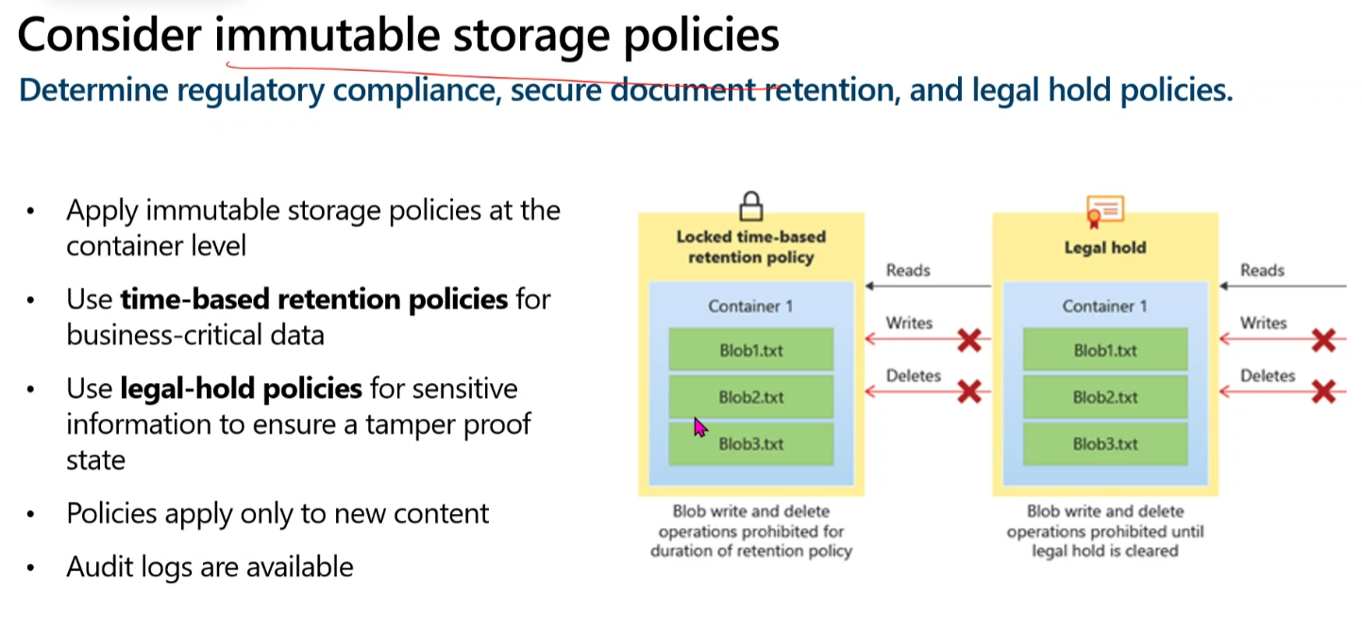

Blob versioning
You can enable Blob storage versioning to automatically maintain previous versions of an object. When blob versioning is enabled, you can access earlier versions of a blob to recover your data if it's modified or deleted.
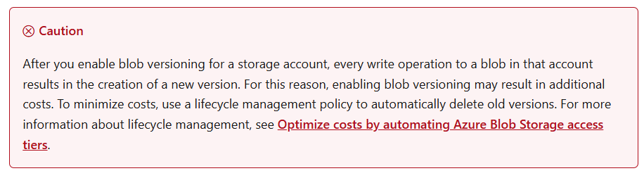
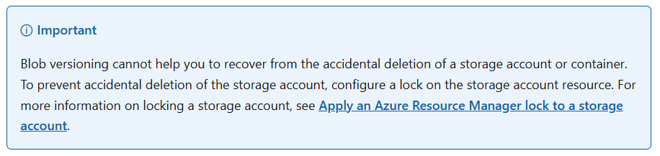
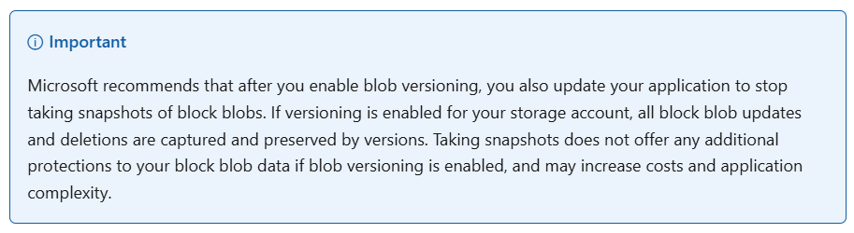
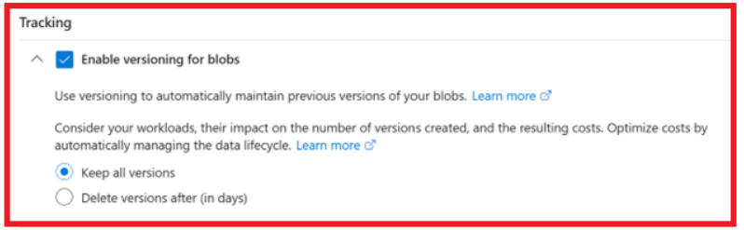
In Azure Blob Storage, versioning is applied at the storage account level, but it works per blob — meaning:

✅ Versioning is enabled for the entire storage account, but:
- Each blob within containers will maintain its own versions only when it changes.
- So, versioning is per-blob, but cannot be selectively enabled per blob or container.

Lock
Apply an Azure Resource Manager lock to a storage account
Microsoft recommends locking all of your storage accounts with an Azure Resource Manager lock to prevent accidental or malicious deletion of the storage account. There are two types of Azure Resource Manager resource locks:
- A CannotDelete lock prevents users from deleting a storage account, but permits reading and modifying its configuration.
- A ReadOnly lock prevents users from deleting a storage account or modifying its configuration, but permits reading the configuratio

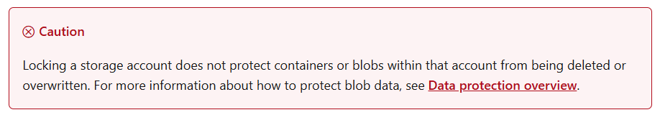

Object replication
Object replication asynchronously copies block blobs between a source storage account and a destination account. When you configure object replication, you create a replication policy that specifies the source storage account and the destination account. A replication policy includes one or more rules that specify a source container and a destination container and indicate which block blobs in the source container will be replicated.

ETag
Optimistic concurrency
Azure Storage assigns an identifier to every object stored. This identifier is updated every time a write operation is performed on an object. The identifier is returned to the client as part of an HTTP GET response in the ETag header defined by the HTTP protocol

Understanding ETag in Azure Storage Table
ETag (Entity Tag) is a property used in Azure Storage Table for optimistic concurrency control during updates. It ensures that multiple users do not overwrite each other's changes when editing the same entity. The ETag is not a timestamp; there is a separate property called Timestamp that stores the last update time of a record¹³.
Purpose of ETag
When an entity is loaded from the Azure Storage Table, it comes with an ETag value. This ETag value is used to track changes to the entity. If you want to update the entity, you must provide the same ETag value that was originally loaded. If the ETag matches the current ETag stored in the table, the update proceeds. If it does not match, it indicates that the entity has been modified by another user, and the update is rejected¹³.

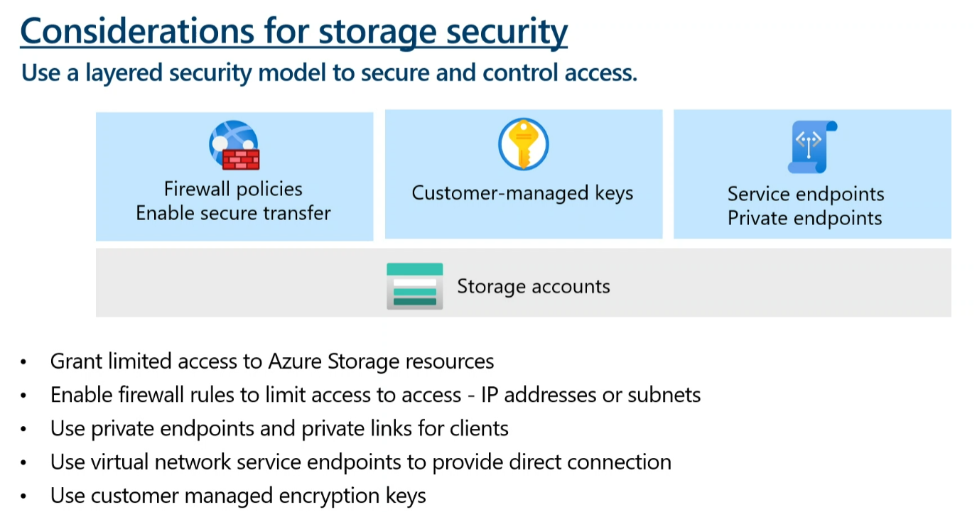

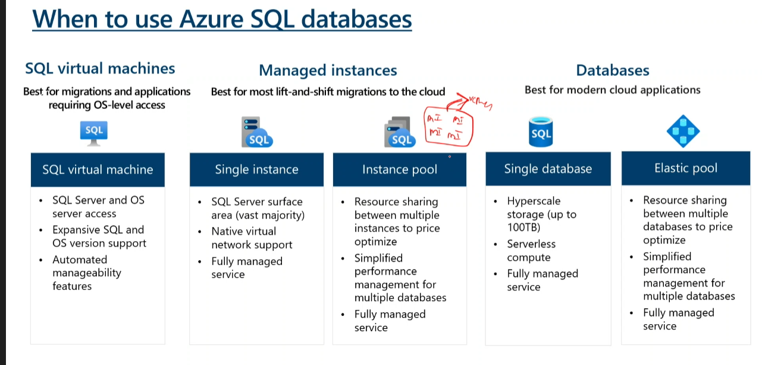

🔄 Scenario Recap:
You have 10 GB of data and:
- Store in Cool tier → for 10 days
- Move to Archive tier
- After 20 days in Archive, you rehydrate to Hot

🚨 Here's how Azure will bill you:
Step | Tier | Days Used | Charged For | Why?
1 | Cool | 10 days | 30 days | ❗ Minimum charge duration for Cool is 30 days
2 | Archive | 20 days | 180 days | ❗ Minimum charge duration for Archive is 180 days
3 | Hot | Immediate | Billing starts from the day you rehydrate | Regular Hot billing applies from this point

🧾 Cost Breakdown Summary:
👇 You're charged for:
- 30 days of Cool tier (even though you only stayed for 10)
- 180 days of Archive tier (even though you rehydrated after 20)
- Hot tier starts billing the day you rehydrate, and continues as long as the blob stays in Hot

✅ Important:
- Azure doesn’t “stop” Archive billing once you rehydrate.
You’ll still be charged for the full 180 days for that 10 GB at Archive rate.
- Hot billing is added from the moment you rehydrate, meaning both tiers will be billed during overlapping periods.

💡 Total Effective Cost:
You’re paying:
- 30 days Cool
- 180 days Archive
- Hot usage from rehydration onward
💸 So the rehydration doesn’t replace Archive billing — it just adds Hot billing on top after the blob becomes accessible again.

What is Azure Import/Export service?
Azure Import/Export service is used to securely import large amounts of data to Azure Blob storage and Azure Files by shipping disk drives to an Azure datacenter. This service can also be used to transfer data from Azure Blob storage to disk drives and ship to your on-premises sites. Data from one or more disk drives can be imported either to Azure Blob storage or Azure Files.
Supply your own disk drives and transfer data with the Azure Import/Export service. You can also use disk drives supplied by Microsoft.
If you want to transfer data using disk drives supplied by Microsoft, you can use Azure Data Box Disk to import data into Azure. Microsoft ships up to 5 encrypted solid-state disk drives (SSDs) with a 40 TB total capacity per order, to your datacenter through a regional carrier. You can quickly configure disk drives, copy data to disk drives over a USB 3.0 connection, and ship the disk drives back to Azure. For more information, go to Azure Data Box Disk overview.
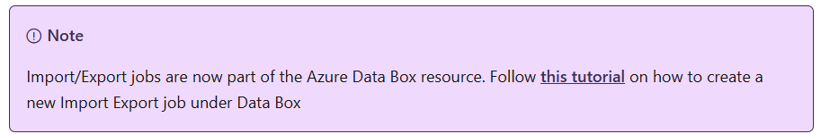
Azure Import/Export use cases
Consider using Azure Import/Export service when uploading or downloading data over the network is too slow, or getting additional network bandwidth is cost-prohibitive. Use this service in the following scenarios:
- Data migration to the cloud: Move large amounts of data to Azure quickly and cost effectively.
- Content distribution: Quickly send data to your customer sites.
- Backup: Take backups of your on-premises data to store in Azure Storage.
- Data recovery: Recover large amount of data stored in storage and have it delivered to your on-premises location.
Import/Export components
Import/Export service uses the following components:
- Import/Export service: This service available in Azure portal helps the user create and track data import (upload) and export (download) jobs.
- WAImportExport tool: This is a command-line tool that does the following:
  - Prepares your disk drives that are shipped for import.
  - Facilitates copying your data to the drive.
  - Encrypts the data on the drive with AES 256-bit BitLocker. You can use an external key protector to protect your BitLocker key.
  - Generates the drive journal files used during import creation.
  - Helps identify numbers of drives needed for export jobs.
